**Library Management Simulation**

Contents

REQUIREMENTS 2

Pages- 2

Databases- 2

Functional Requirements- 3

Data Flow Diagram 5

ER Diagram 6

Relationships between Entities – 7

WHY LIBRARY MANAGEMENT SYSTEM IS NEEDED ? 7

HOW LIBRARY MANAGEMENT SYSTEM WORKS 8

SYSTEM DESIGN 8

SYSTEM IMPLEMENTATION 13

Registration page 13

Index Page 14

Admin: 16

Student : 18

Teachers: 20

Guest: 21

Table of figures

Figure 1 - DFD for LMS 4

Figure 2 - ER Diagram for LMS 5

Figure 3 - Tables required in the system 7

Figure 4 - Students Table 8

Figure 5 - Books Table 8

Figure 6 - Guests Table 9

Figure 7 - Issued Books Table 9

Figure 8 - Question Paper Table 10

Figure 9 - Teachers Table 10

Figure 10 - Registration Page 11

Figure 12 - Login form 12

Figure 11 - Index Page / Landing Page 12

Figure 13 - Invalid credentials message alert 13

Figure 14 - Admin Dashboard 14

Figure 15 - Add Book Form For Admin 14

Figure 16 - Add Question Paper Form for Admin 15

Figure 17 - Students Page 16

Figure 18 - Question Papers Display / Download Page 16

Figure 19 - Student's Setting and Logout Page 17

Figure 20 - Teacher's Landing Page 18

Figure 21 - Guest's Landing Page 19

Figure 22 - Downloaded csv files 20

# REQUIREMENTS

## Pages-

1. Home Page
2. Login Page for admin, teachers, students, and guests.
3. Logout Page for admin, teachers, students, and guests.
4. New user registration page
5. Password recovery page
6. List of books page
7. List of papers page
8. Student details page
9. Teacher details page
10. Admin page

## Databases-

1. Students detail table.
2. Teachers detail table.
3. Books detail table.
4. Papers detail table.
5. Guests table.
6. Issued Books table.

## Functional Requirements-

1. Student
   1. Student Login

* Student runs the system, system requests for student id and password.
* The student with valid id and password can only be permitted to use the library services.
* The student should be able to logout after he/she finishes using the system.
  1. Password Recovery
* If a student forgets his/her password. He/she requests for password recovery to the system.
* System validates the user and sends the correct password to the student’s registered mail.
  1. Search and issue the book.
* The student will enter the name of the book he wants to issue.
* The system will find the books based on the text entered and display the list.
* The student if finds the book will issue it.
* The details such as the issue date of the book, name of the student, book ISBN and name are stored in the database and the available count of books is changed.
  1. Search the previous year papers.
* Student can search for the previous year papers.
* On viewing the list of paper displayed by the system, the student can download the papers.

1. Teacher

2.1) Teacher Login

* Teacher runs the system, system request for teacher’s id and password.
* Teacher with valid id and password can only access further
* Teacher should be able to logout after he/she finishes using the system.

2.2) Password recovery

* If a teacher forgets his/her password. He/she requests for password recovery to the system.
* System validates the user and sends the correct password to the teacher’s registered mail.

2.3) Upload papers

* Teachers can upload a pdf/picture file of the question paper and fill its complete details in the database.

1. Guest

3.1) Guest login

* Guest will not have user id and password; they will have to enter email and ask the system to provide them access.
* Guest must be able to logout.

1. Librarian

4.1) Librarian Login

* Librarian by entering the id and password logins into system.
* Once librarian’s work finishes, he/she must be able to logout.

4.2) Upload books

* Librarian uploads books and their details to the books table.
* He / She update the count of books in the books count table.

4.3) Update publishers

* The book publisher’s data is maintained by the librarian.

4.4) Maintain student details

* Librarian on searching the student’s name, should be able to see all the books issued by the student with its date.

4.5) Maintain fine table

* The librarian will check if there’s a student needs to be fined or not and whether he/she has paid the fine.

## Data Flow Diagram

Figure 1- DFD for LMS

The overall system is represented and described using input, processing, and output in the DFD.

## ER Diagram

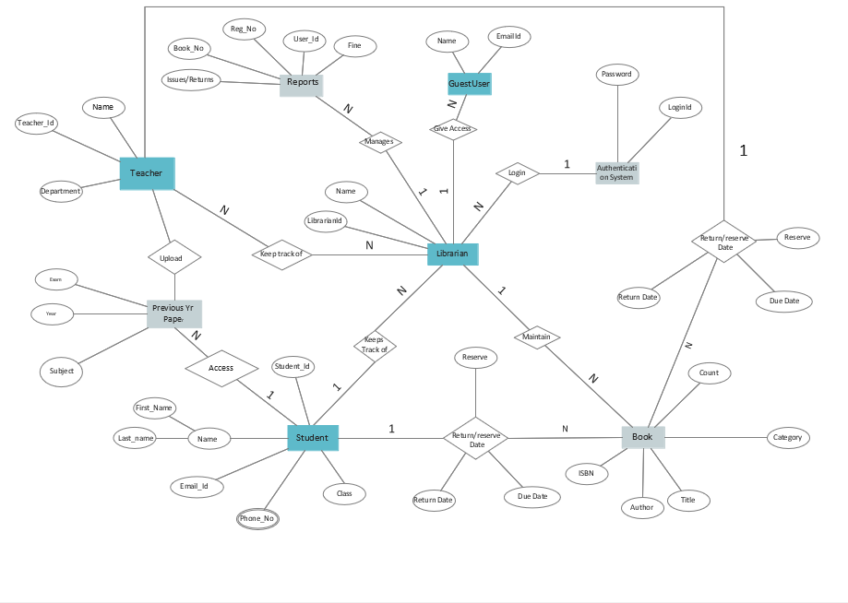

N

1

Figure 2-ER Diagram for LMS

This Library ER diagram tells key information about the Library, including entities such as teachers, students, books, publishers, papers, reports, and authentication system. It gives the relationships between entities.  
  
  
Entities and their Attributes –

* **Librarian Entity:** It has LibrarianId, name as attributes. LibrarianId is the primary key.
* **Book Entity:**It has authno, isbn number, title, edition, category, count, price. ISBN is the Primary Key for Book Entity.
* **Student Entity:**It has UserId, Email, address, phone no, name. Name is composite attribute of firstname and lastname. Phone no is multi valued attribute. UserId is the Primary Key for Readers entity.
* **Publisher Entity:**It has PublisherId, Year of publication, name. PublisherId is the Primary Key.
* **Authentication System Entity:**It has LoginId and password with LoginID as Primary Key.
* **Reports Entity:**It has UserId, Reg_no, Book_no, Issue/Return date, fine, Reg_no is the Primary Key of reports entity.
* **Teachers Entity:**It has name, department, and teacher_id with teacher_id as Primary Key.
* **Paper Entity:** It has exam, year, and subject attributes.
* **GuestUser Entity:** It has name and email_id attributes.
* **Reserve/Return Relationship Set:**It has three attributes: Reserve date, Due date, Return date.

## [Relationships](https://www.geeksforgeeks.org/attributes-to-relationships-in-er-model/)between Entities –

* A student can reserve N books, but one book can be reserved by only one student. The relationship 1: N.
* A publisher can publish many books, but a book is published by only one publisher. The relationship 1: N.
* Librarian keeps track of students. The relationship is 1: N.
* Librarian maintains multiple reports. The relationship 1: N.
* Librarian maintains multiple Books. The relationship 1: N.
* Authentication system provides login to multiple librarians. The relation is 1: N.
* A teacher can upload multiple papers. The relationship is 1: N.
* There can be multiple guest users hence the relationship is 1: N between admin and guest.

# WHY LIBRARY MANAGEMENT SYSTEM IS NEEDED ?

* Managing a library includes tasks like maintaining huge records of each and every library book and library users. Retrieval and updating this data are another tedious task. When libraries where managed manually, it required a lot of time to record or to retrieve the details. Even a small mistake would create a lot of problems. Security of information is very less.
* Maintenance of library books details is a very complex task Along with this maintaining book issue dates, return dates and fine manually would make it very difficult work for the administrator.

# HOW LIBRARY MANAGEMENT SYSTEM WORKS

* The users (students and teachers) register themselves with unique username and password on the system online.
* The users can then use the same for logging in and using the system.
* Books details like the isbn, title, aauthor of book, no of copies available is added by the administrator.
* The details of when a user issues a book, the return date of the book and fine if any can be maintained easily.
* Retrieval of data comes handy with Librray Management System.
* Details regaridng users is available on a click.
* Administrator can add, update and delete the books.
* Time consuming is low, gives accurate results, reliability can be improved with the help of security.

The frontend of the project is developed in html, css and js. The backend is developed in python’s microweb framework flask. Database used is PostgreSQL.

Here are the tables and interface for the Library Management System with Flask and PostgreSQL.

# SYSTEM DESIGN

Various tables required to store data are as follows:

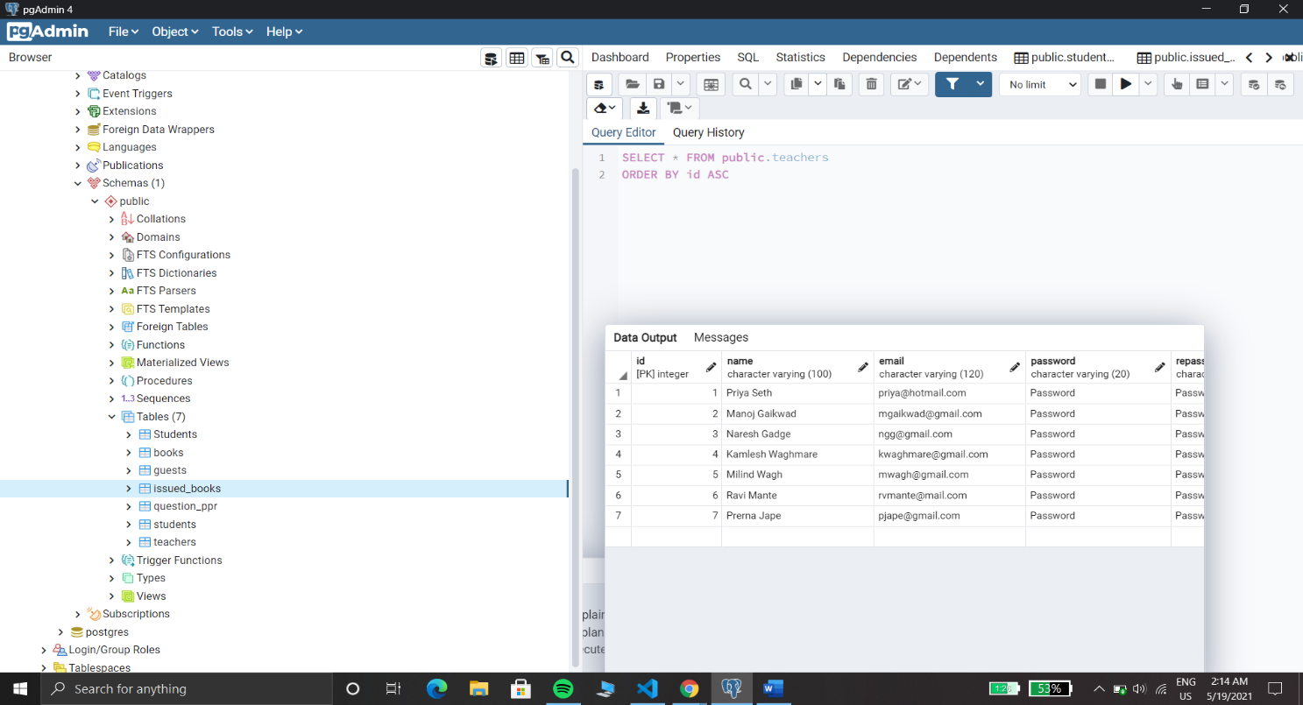

Figure 3 - Tables required in the system

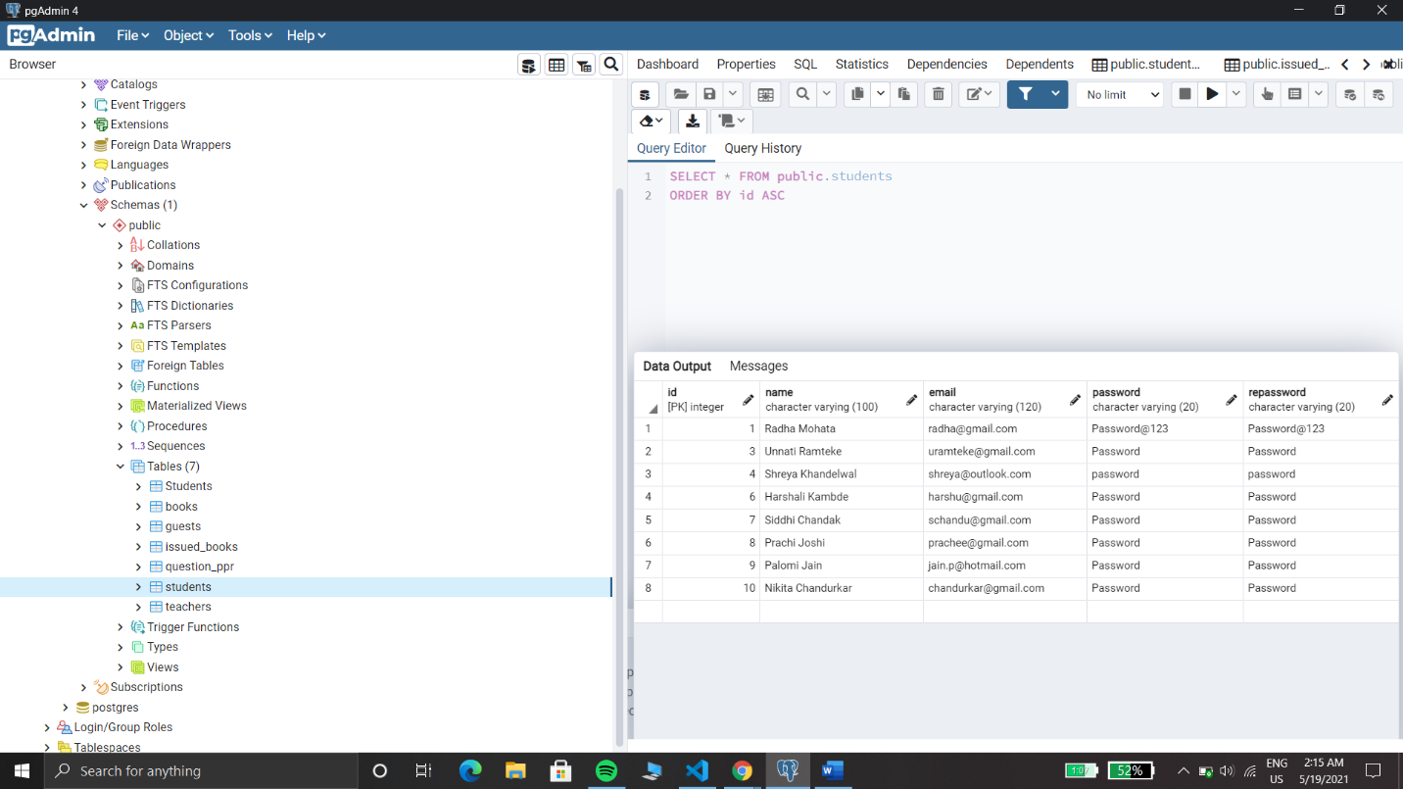

Figure 4- Students Table

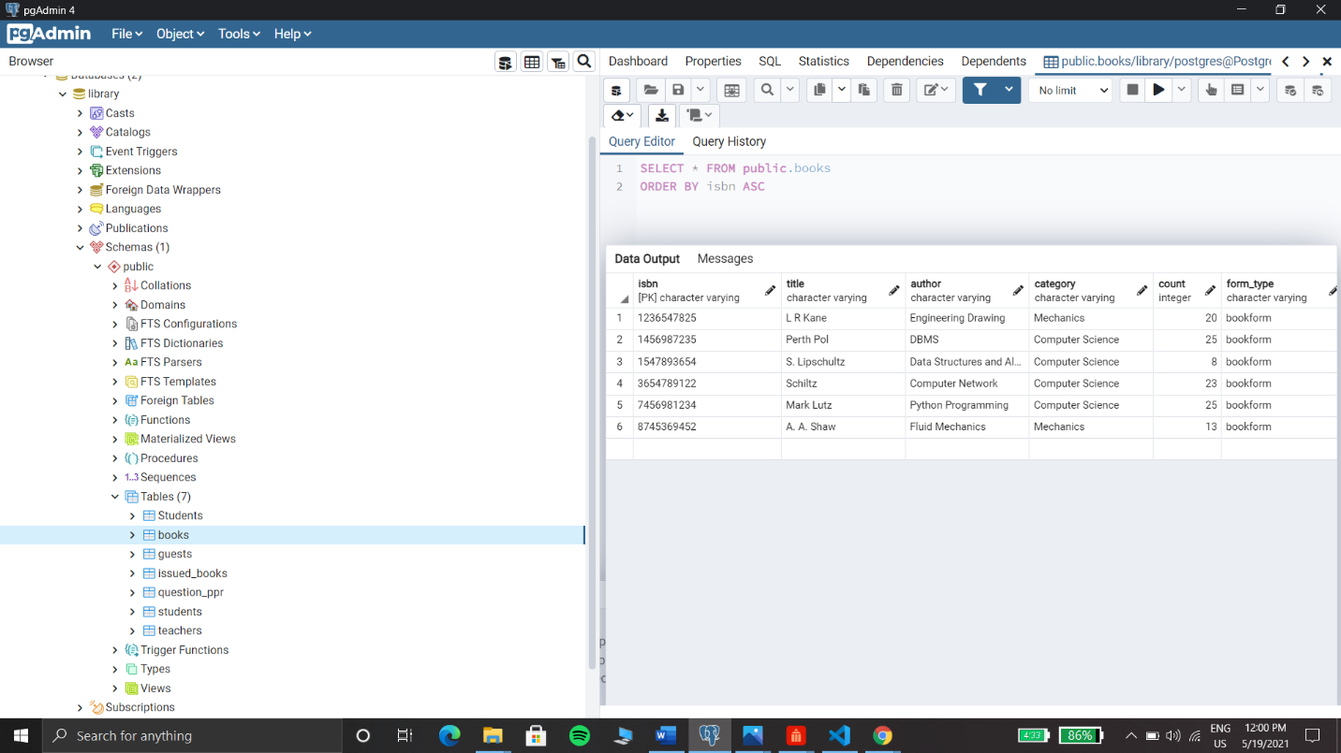

Figure 5- Books Table

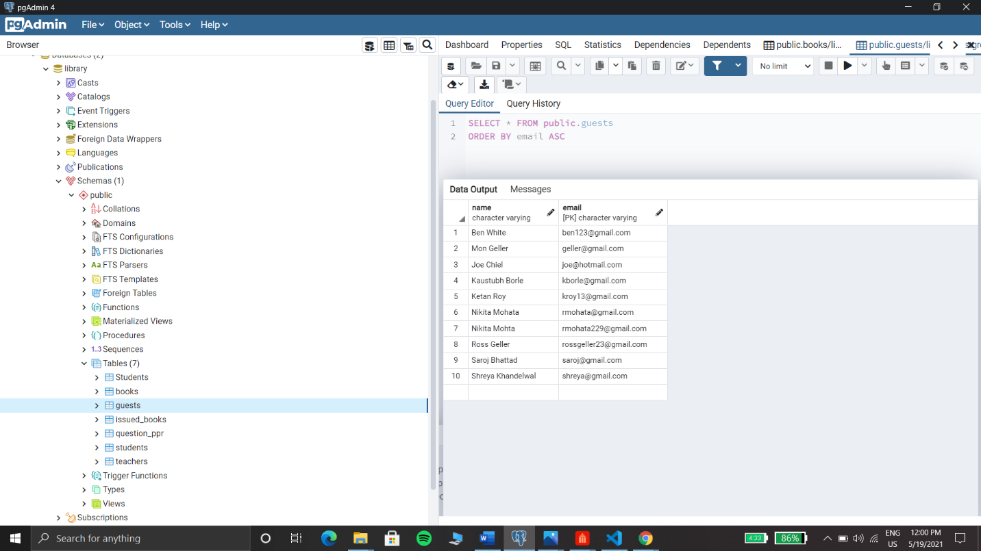

Figure 6 - Guests Table

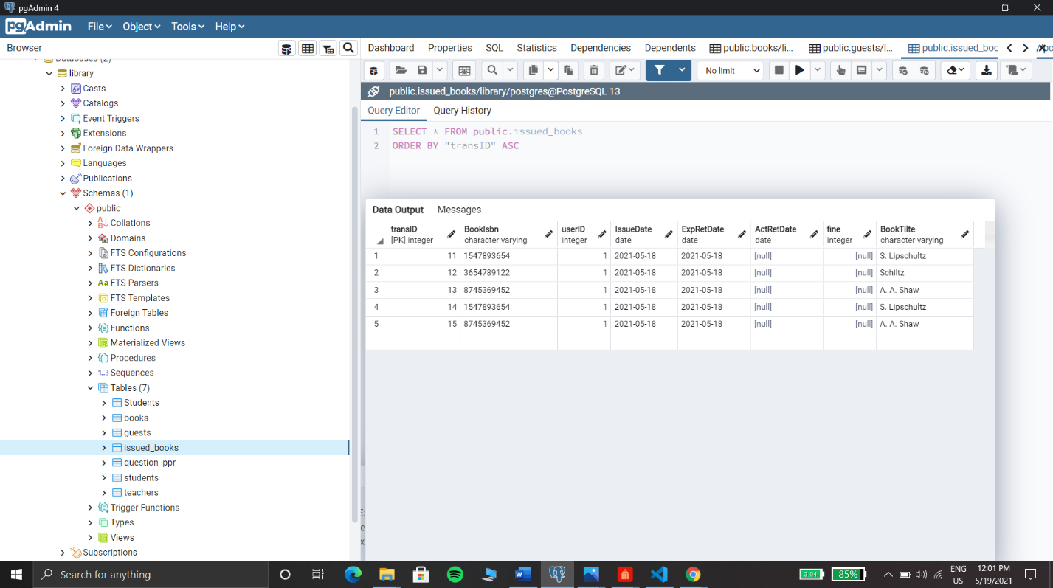

Figure 7-Issued Books Table

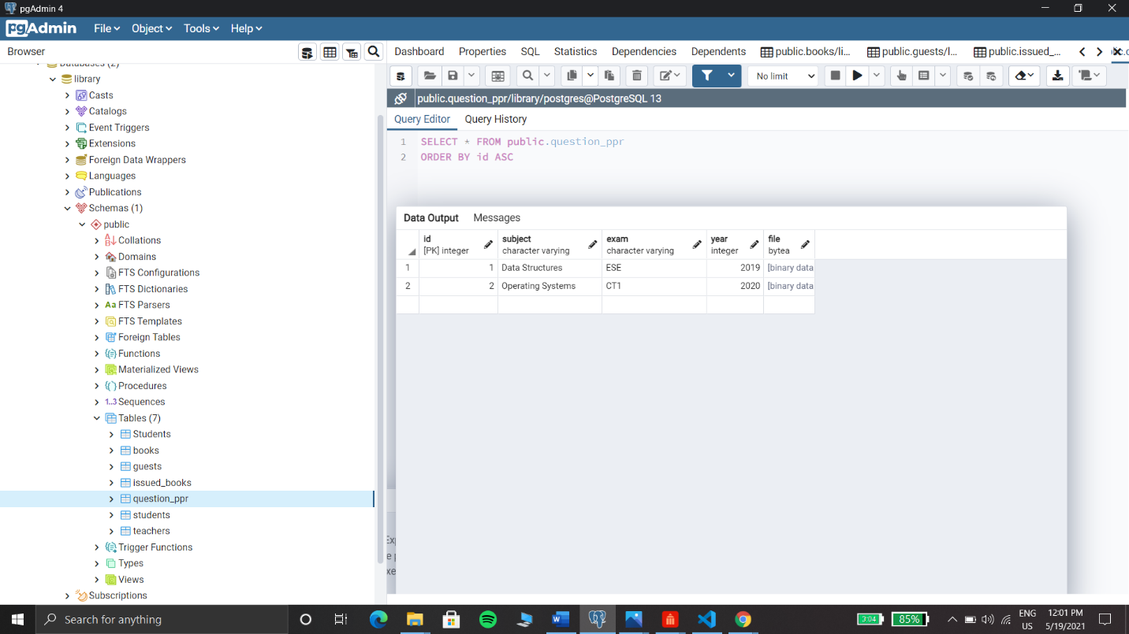

Figure 8- Question Paper Table

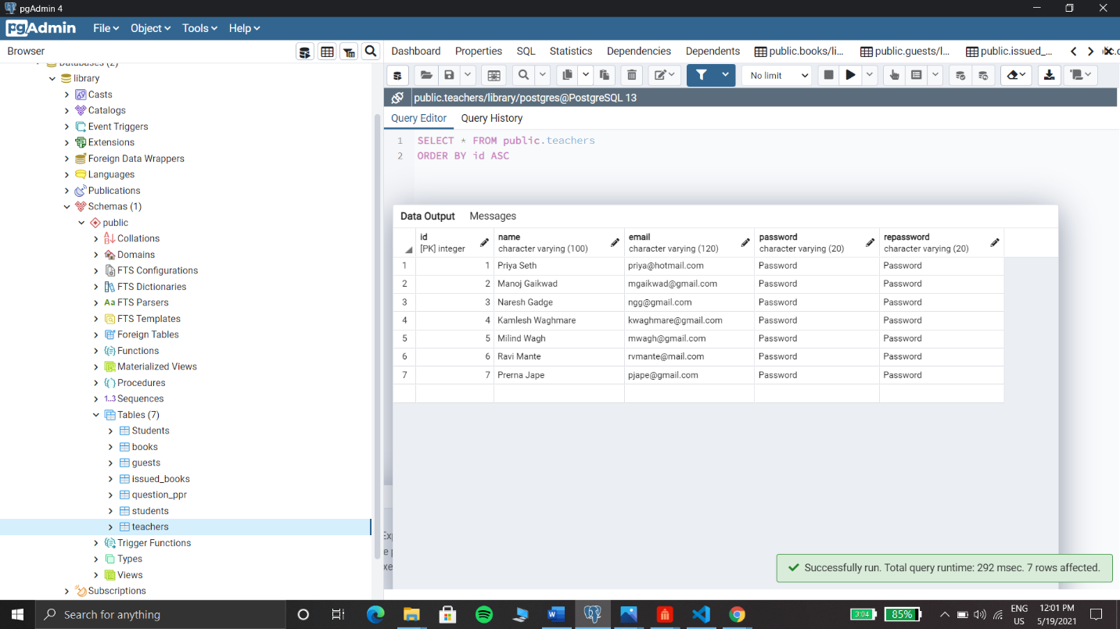

Figure 9 - Teachers Table

# SYSTEM IMPLEMENTATION

## Registration page

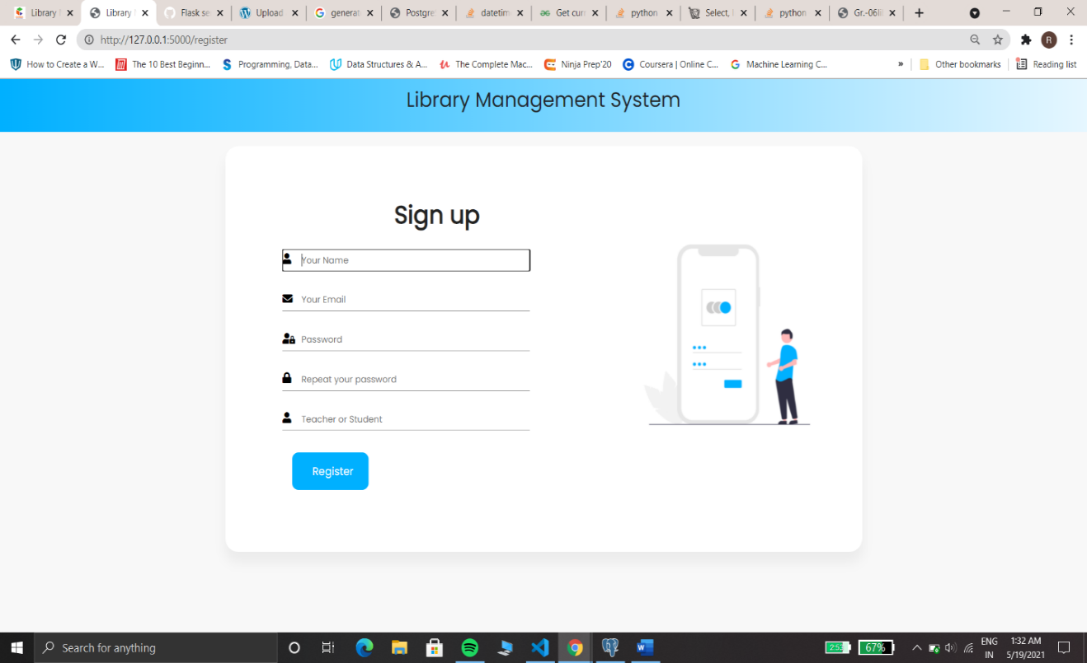

Figure 10 - Registration Page

* Whoever wants to access the library needs to register first.
* The registration asks for the user unique email id, name and asks to set the password that is used for login.
* The role of user whether student or teacher is stored to determine the accessability to the system.

## Index Page

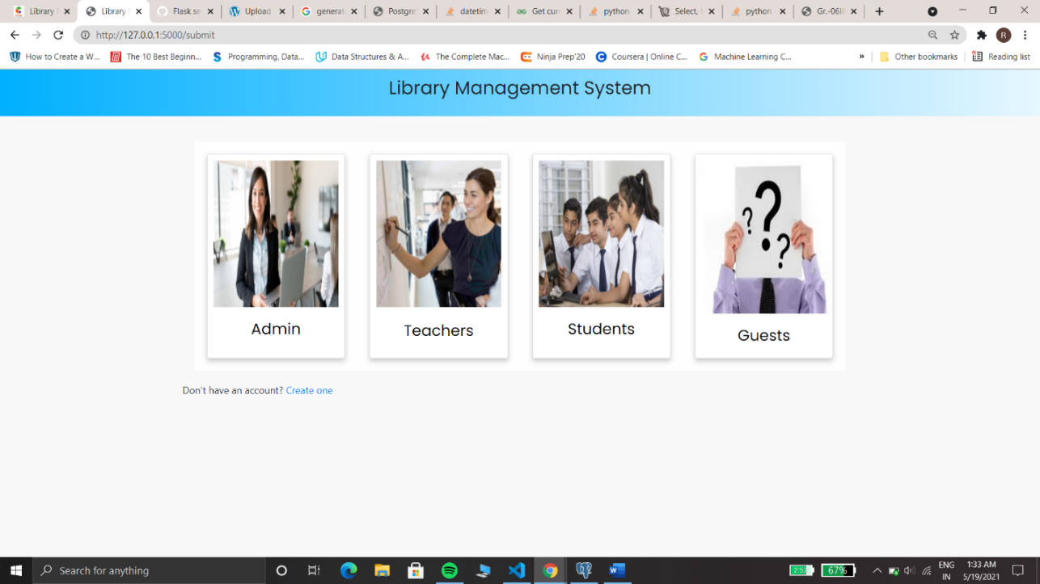

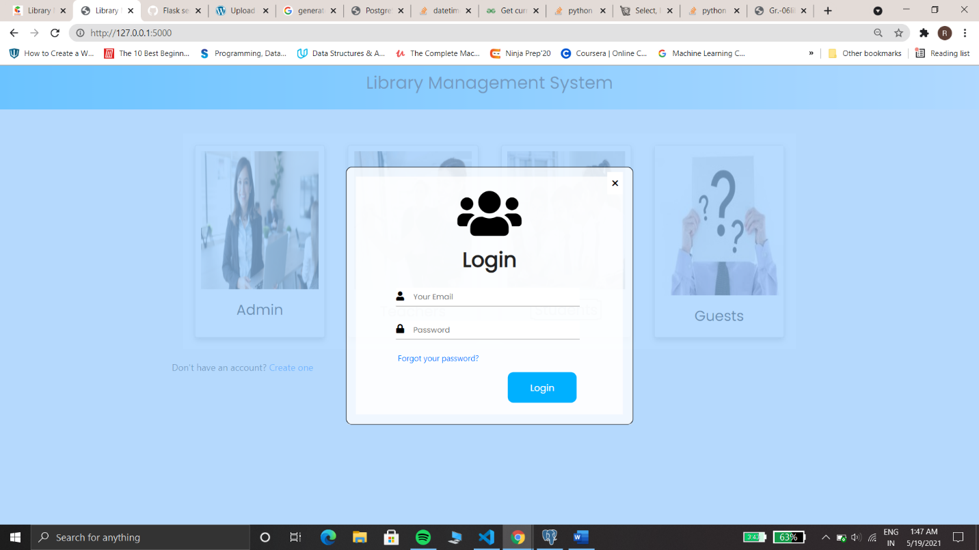Figure 11 - Index Page / Landing Page

Figure 12 - Login form

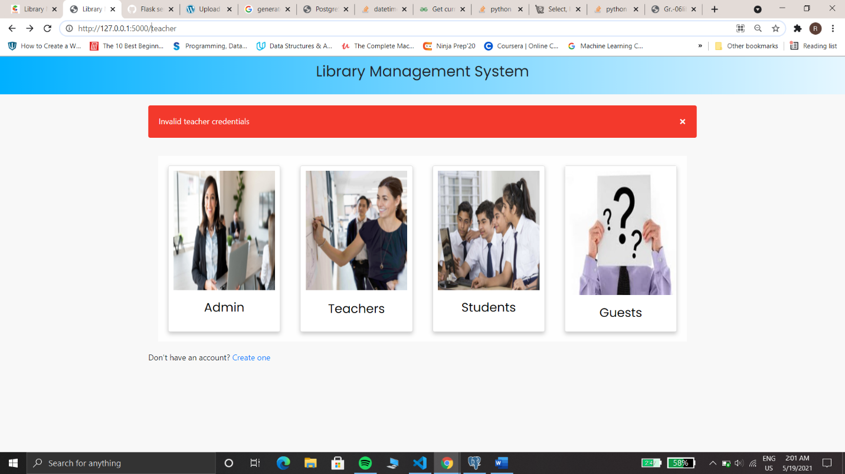

Figure 13 - Invalid credentials message alert

* The index page has different logins for different types of user.
* Authentication for the user is done. If the user credentials are not valid and error message is displayed.
* If someone is not registered but still wishes to access the sytem can do so by logging as a guest.
* Accessability of different users varies according to their roles.

## Admin:

Admin Dashboard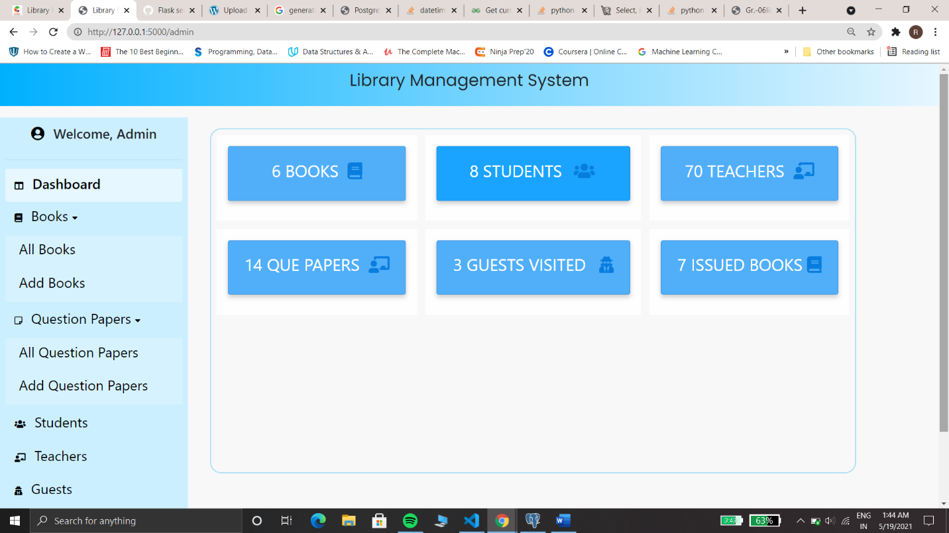

Figure 14 - Admin Dashboard

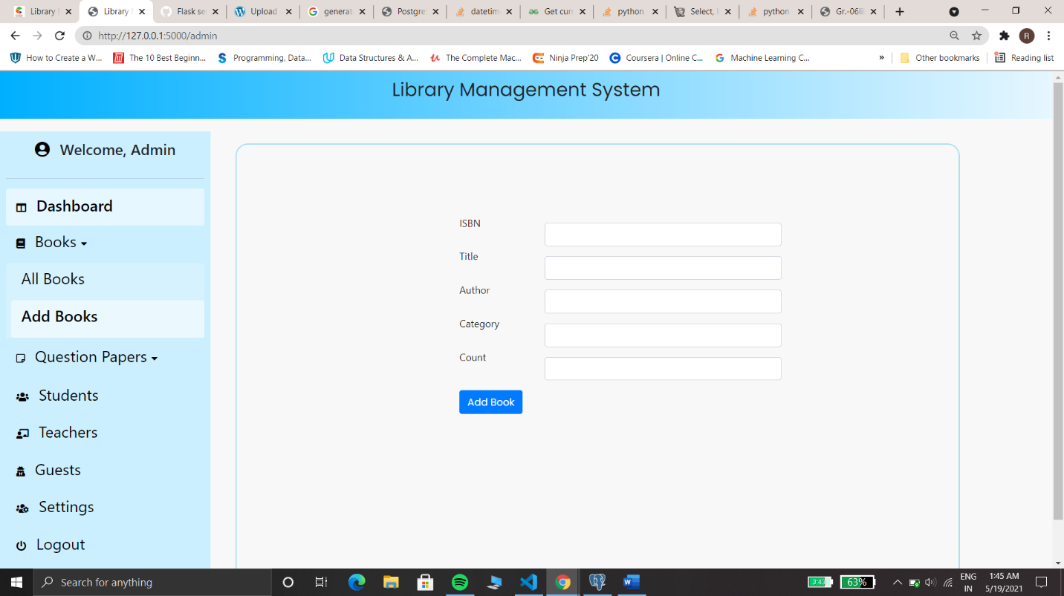

Figure 15 - Add Book Form for Admin

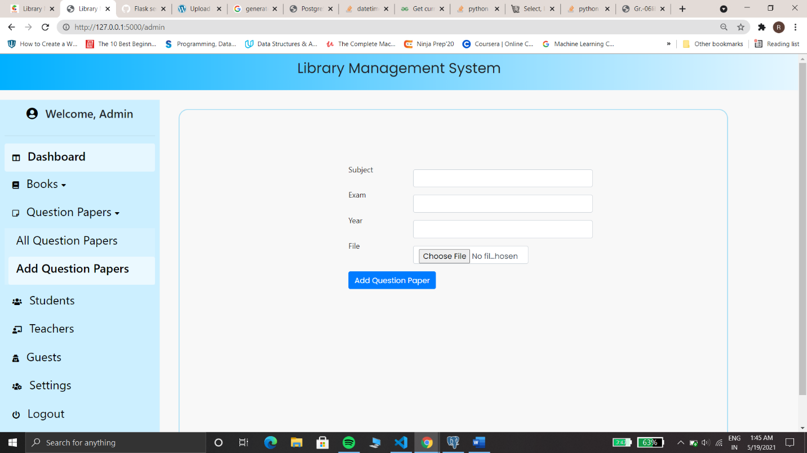

Figure 16 - Add Question Paper Form for Admin

* Library Management System involves storing all information about books available in a library.
* It also offers option to add new subjects and books. The administrator of the library must be able to add and delete books.
* He must be able to delete registered students and teachers.
* The previous exam question papers can be uploaded and deleted by the admin. The question paper file is uploaded which can also be uploaded by the teacher. It can be downloaded by students.

## Student :

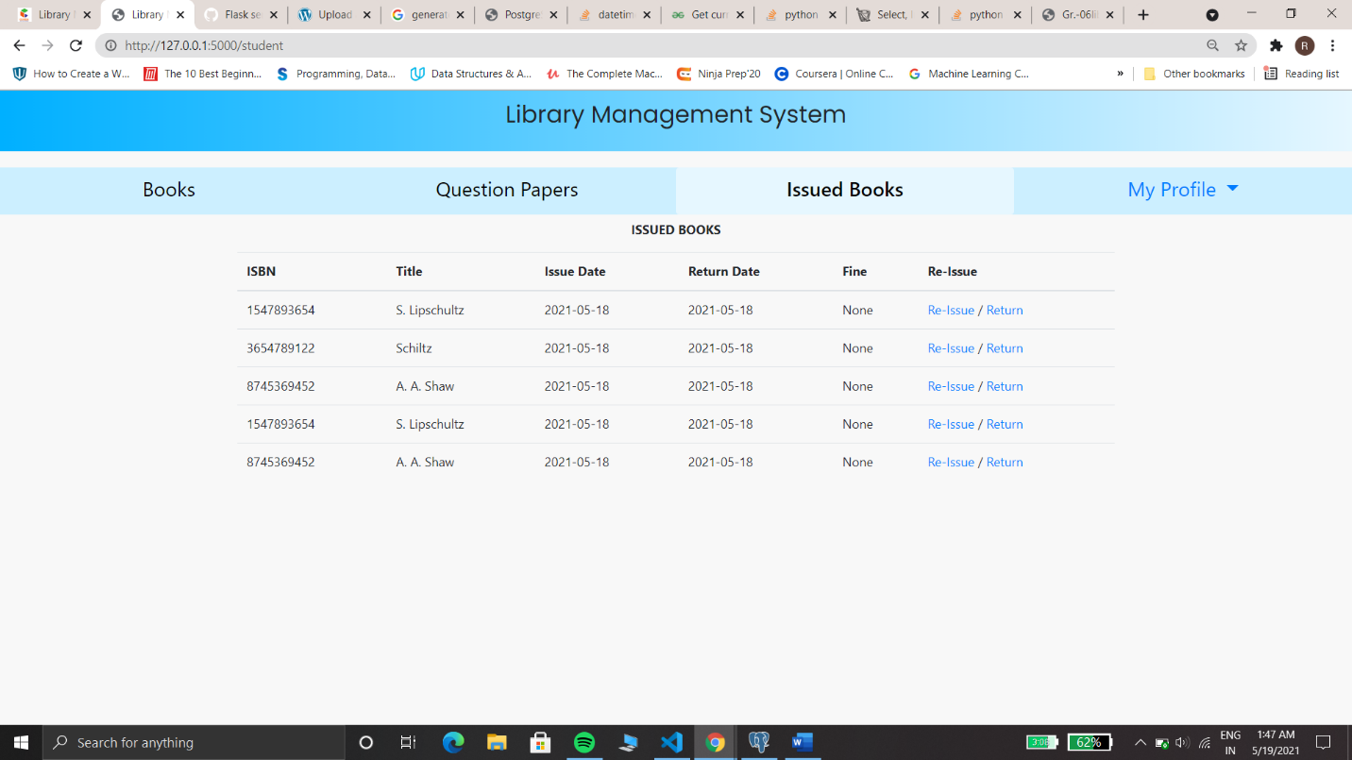

Figure 17 - Students Page

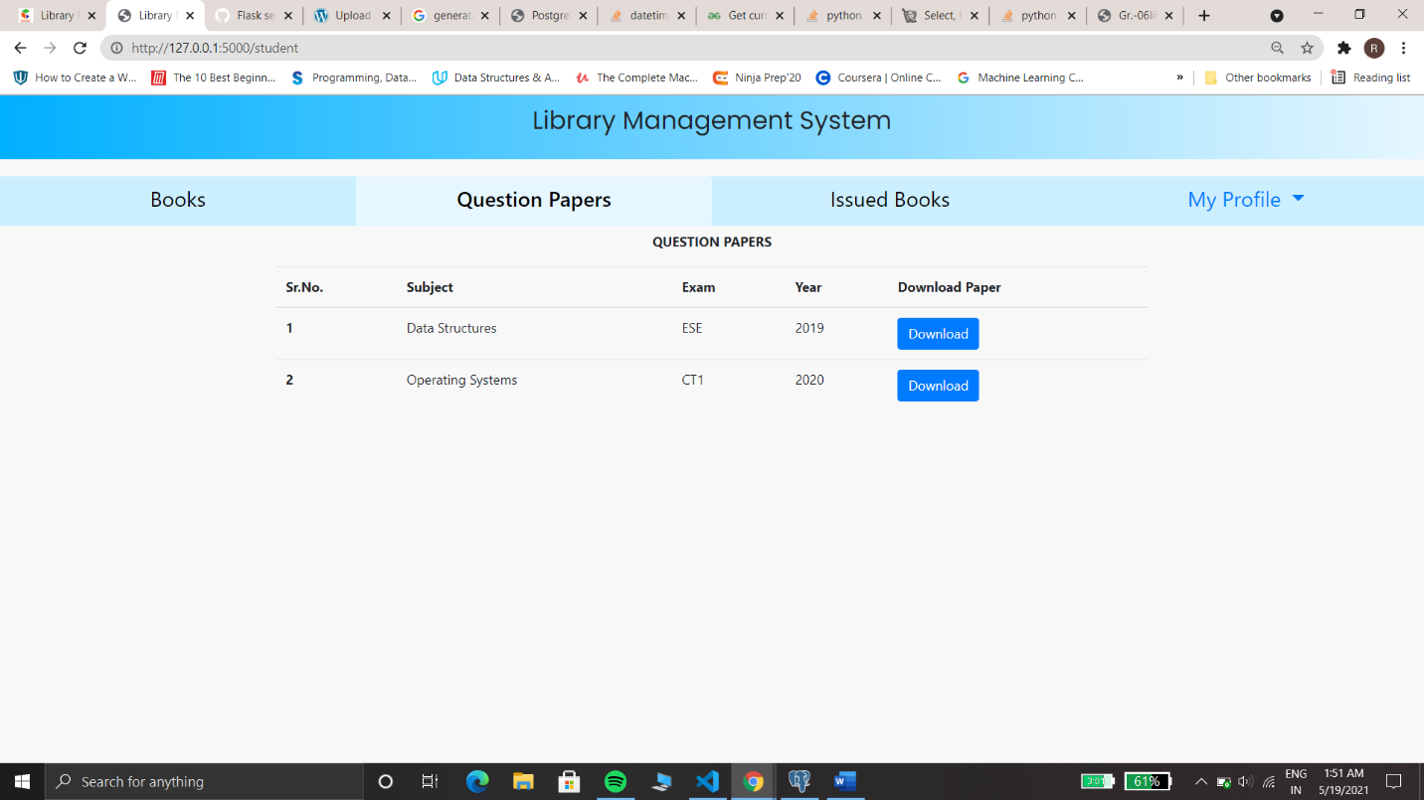

Figure 18 - Question Papers Display / Download Page

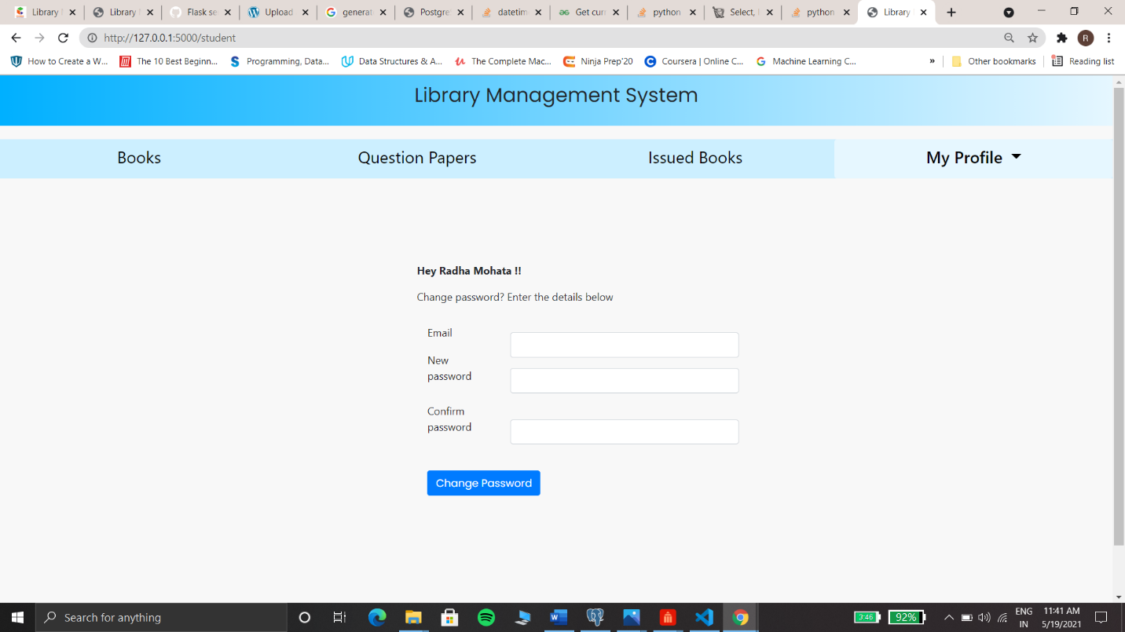

Figure 19 - Student's Setting and Logout Page

* Students on login with the registered credentials have access to the list of books that are in the library, question papers that can be downloaded and his/her issued books.
* The list of books displays 10 books per page.
* The student can issue at most 5 books from the list of books. After 15 days from the issue date, he/she will be fined.
* He/she can download the list of books as a csv file.
* The list of issued books by him/her can be viewed . The issued books can be returned or re-issued.
* Logout and settings option for student is available in “my profile” section.

## Teachers:

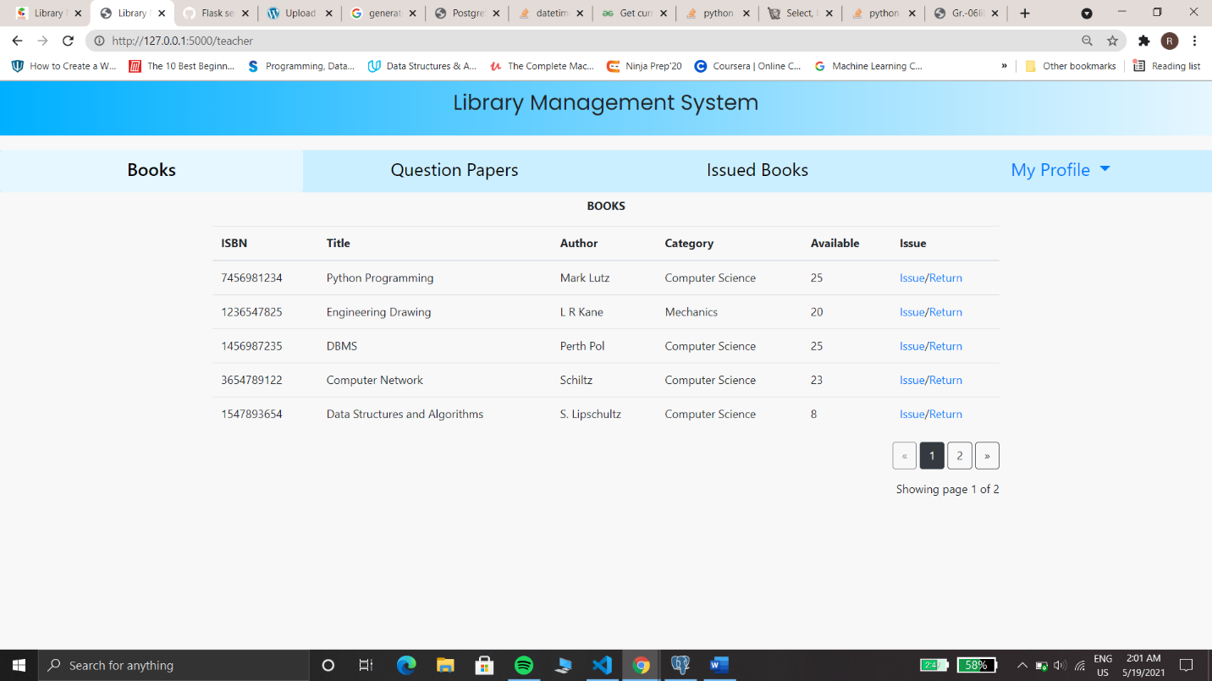

Figure 20 - Teacher's Landing Page

* On login with correct credentials, the teachers can access the list of books, issue and return books.
* Teachers have the access to uploading the question papers .
* If a teacher wants to change his/her login password he/she can do that in my profile section.
* The logout function will end the teacher’s session.

## Guest:

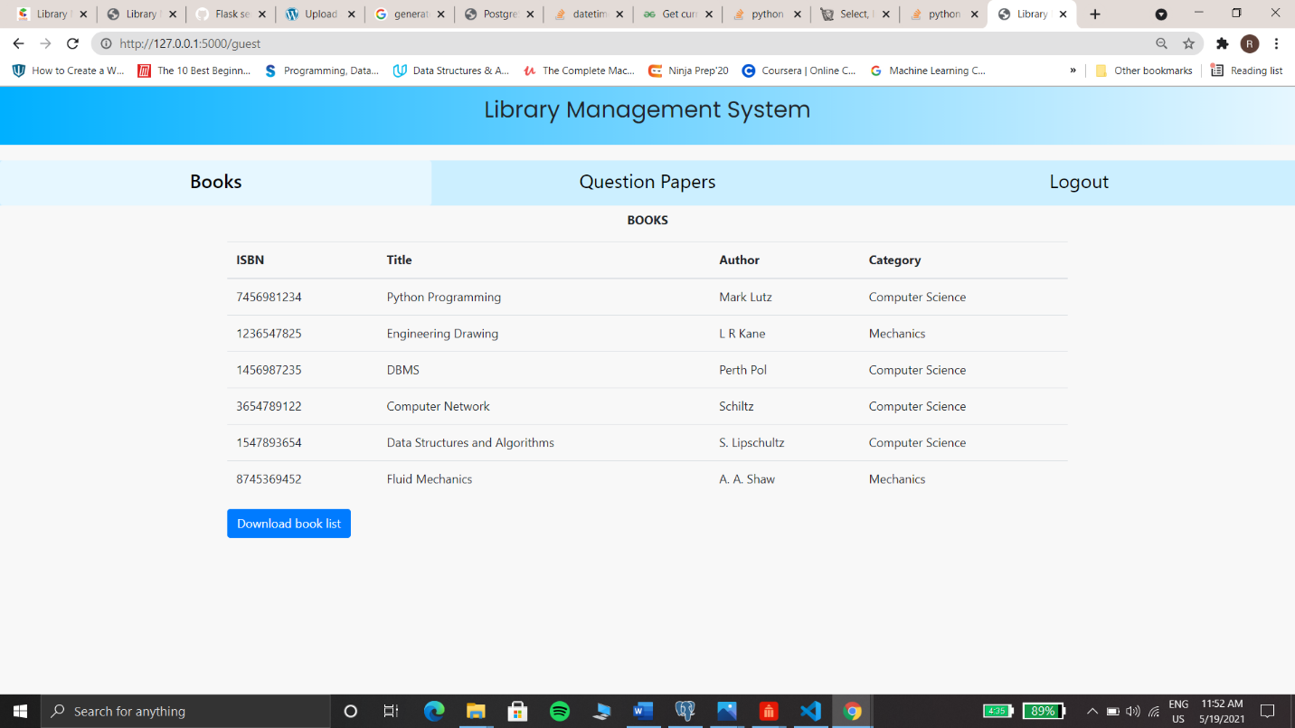

Figure 21 Guest's Landing Page

* Guests are the one who are not registered on the system but wish to visit the library.
* He/she has access to the list of books but cannot issue it.
* One guest with his/her unique email address can only visit the site once. He/she will not be allowed for the next time.
* He/she can download the book list as the csv file.
* Guests will have the logout functionality.

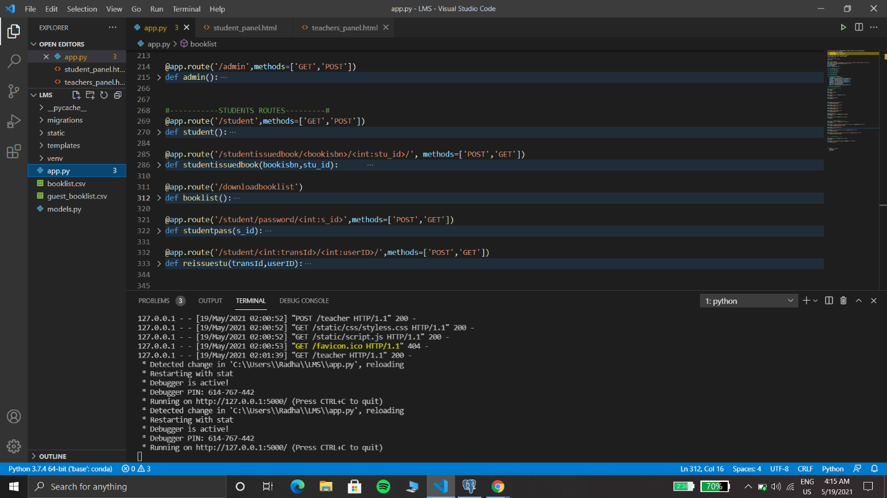

Figure 22 - Downloaded csv files